**MOBILE PROGRAMMING**

**LAB 5: ASYNCTORAGE & FETCH API/ AXIOS (PART II)**

**B1. Create App React Native**

* **Install chocolate in window**

**Mở cmd với quyền admin**

**>**@"%SystemRoot%\System32\WindowsPowerShell\v1.0\powershell.exe" -NoProfile -InputFormat None -ExecutionPolicy Bypass -Command "iex ((New-Object System.Net.WebClient).DownloadString('https://chocolatey.org/install.ps1'))" && SET "PATH=%PATH%;%ALLUSERSPROFILE%\chocolatey\bin"

**>choco**

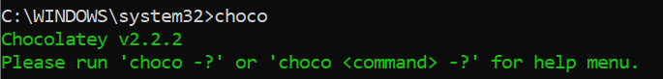

* **Install Node and JDK**

**>**choco install -y nodejs-lts microsoft-openjdk17

>node –v



>java –version

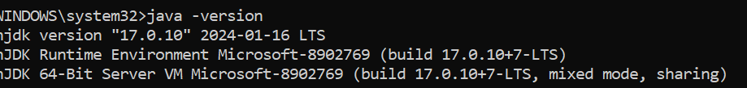

* **Install Android Studio**

> choco install androidstudio

* **Install the Android SDK**
  + **Android SDK Platform 34**
  + **Intel x86 Atom_64 System Image or Google APIs Intel x86 Atom System Image**
  + **Android SDK Build-Tools** 34.0.0
  + **Install HAXM**

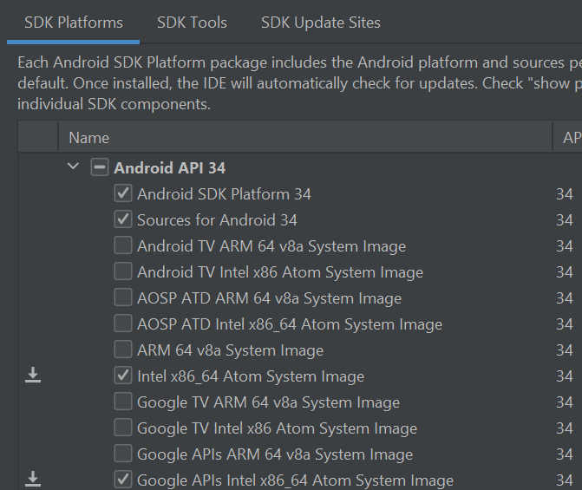

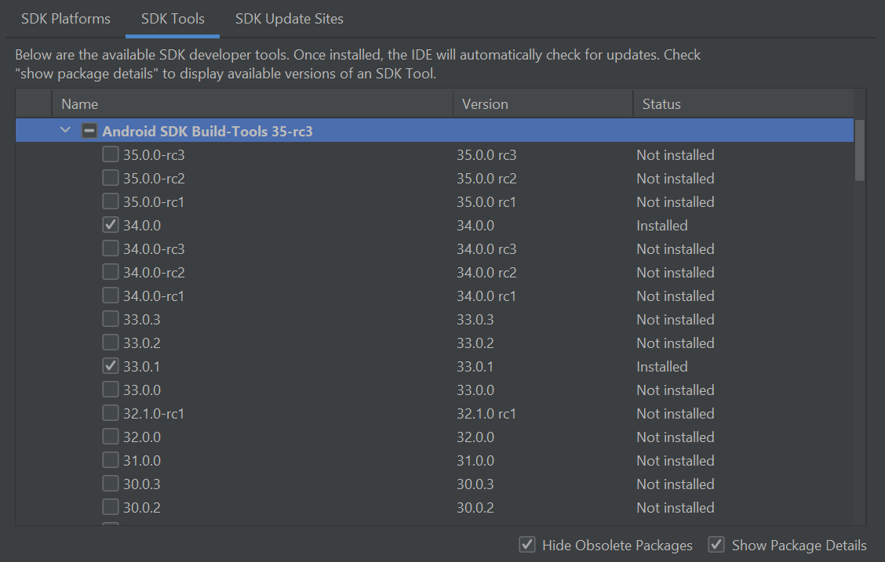



* **Configure user environment variable**
  + **Chú ý cấu hình User Variables không phải system variable**
  + **ANDROID_HOME:** %LOCALAPPDATA%\Android\Sdk
  + **Add platform-tools to Path:** %LOCALAPPDATA%\Android\Sdk\platform-tools

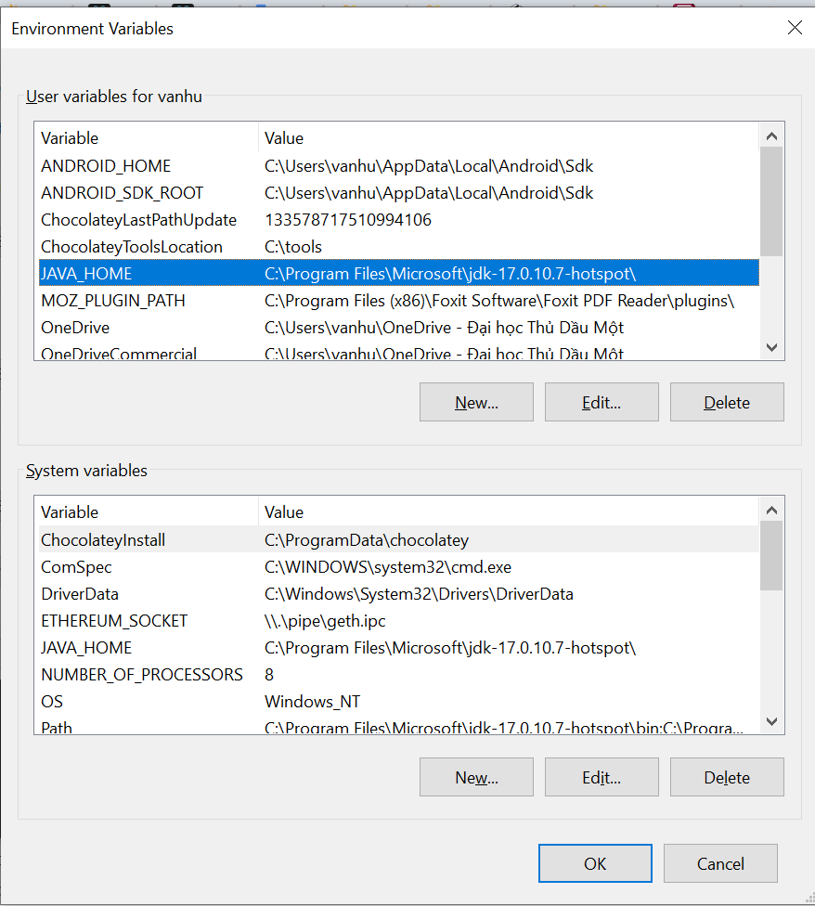

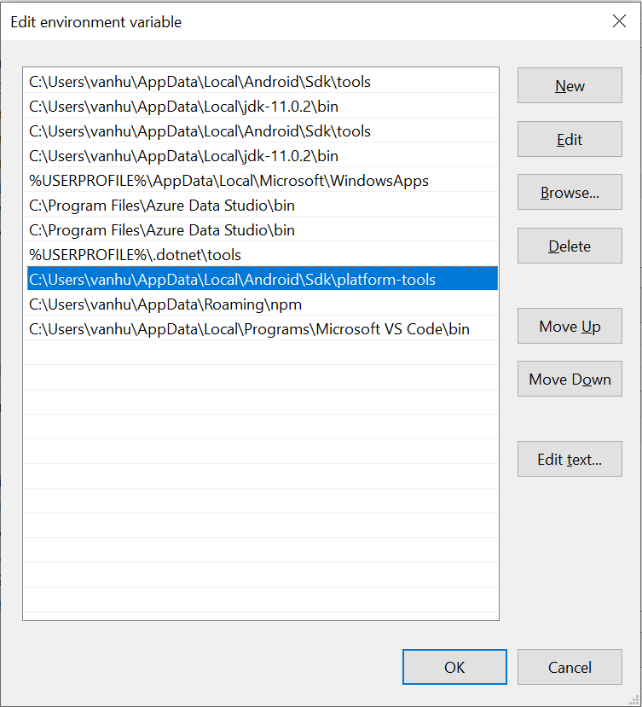

* **Install Máy Ảo Android**
* **Install** react-native-cli new version

>npm uninstall -g react-native-cli @react-native-community/cli

* **Creating a new application**

>npx react-native@latest init Lab3

**B2. Config React Native Firebase**

* **Truy cập firebase console:** [**https://console.firebase.google.com/**](https://console.firebase.google.com/) **=> Add Project**
* **Create firebase app cho android | IOS**

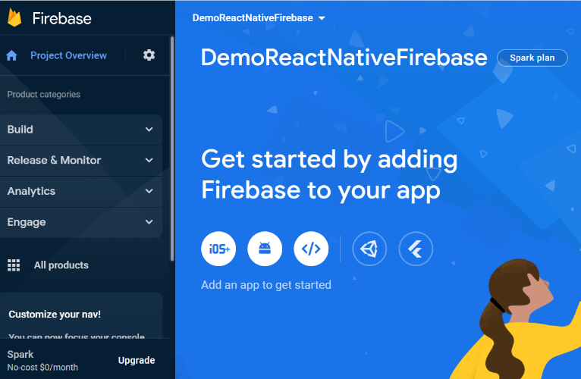

* **Cấu hình package name**

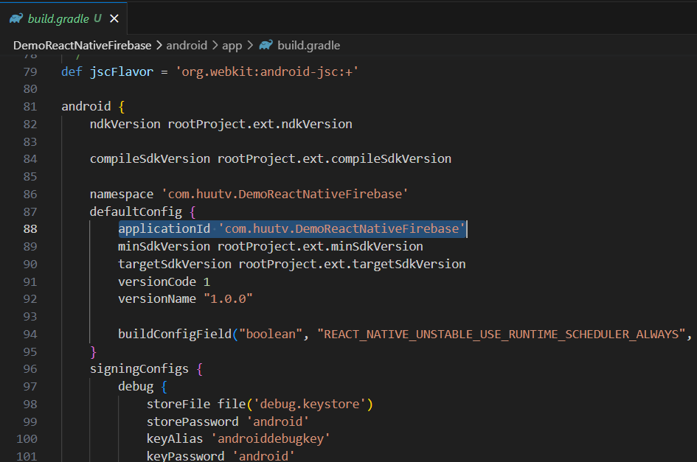

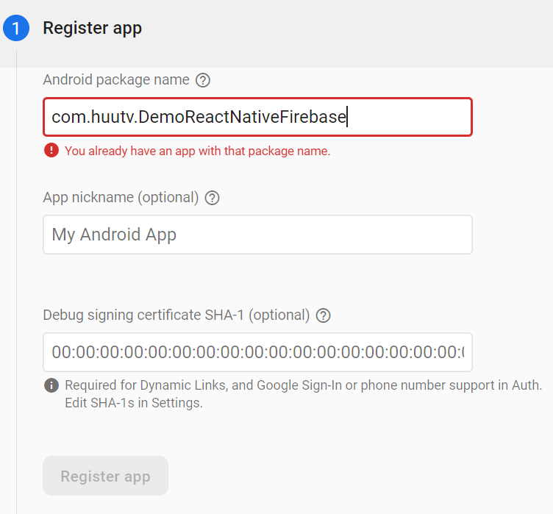

* **Generate Certificate :**

**>** **cd android**

**>** **./gradlew signingReport**

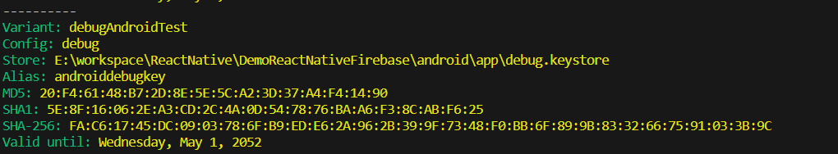

* **Download the google-services.json (/android/app/google-services.json)**

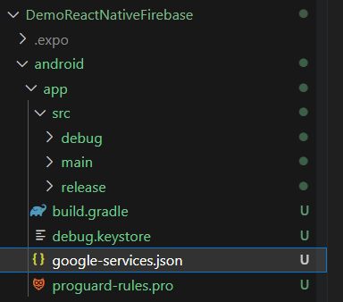

* **Edit /android/build.gradle**

buildscript {

dependencies {

*// ... other dependencies*

*// NOTE: if you are on react-native 0.71 or below, you must not update*

*// the google-services plugin past version 4.3.15 as it requires gradle >= 7.3.0*

classpath 'com.google.gms:google-services:4.4.1'

*// Add me --- /*

}

}

* **Edit /android/app/build.gradle**

apply plugin: 'com.android.application'

apply plugin: 'com.google.gms.google-services' *// <- Add this line*

* **React Native Firebase không thể cấu hình trên expo. Do expo không có native code. Do đó phải sinh native code ( folder android , ios) với lệnh sau**

>npx expo prebuild

>npx expo run:android

>npx expo run:iOS

**B3. Install Pakages**

* React Native Papper: <https://callstack.github.io/react-native-paper/docs/guides/getting-started>
* React Navigation : <https://reactnavigation.org/docs/getting-started>
  + Stack Navigation: <https://reactnavigation.org/docs/stack-navigator>
  + Bottom Tab Navigation : <https://reactnavigation.org/docs/bottom-tab-navigator>
  + Hoặc Material Bottom Tabs: <https://reactnavigation.org/docs/material-bottom-tab-navigator>

npm install react-native-paper react-native-safe-area-context react-native-vector-icons @react-navigation/native react-native-screens react-native-safe-area-context @react-navigation/bottom-tabs @react-navigation/material-bottom-tabs

**B4.  Start your application**

npm run android

***Chú ý: React native firebase không thể chạy trong ứng dụng Expo go trên máy ảo hoặc device do cấu hình với Native Code. Tuy nhiên Expo project cho phép install app trực tiếp qua thiết bị hoặc máy ảo android / ios nhưng phải cấu hình máy ảo android tương tự react native project. Và run với lệnh***

npm run android  ***không chạy lệnh npx expo start***

**B5.  Design App**

**Screen 1: Login Screen 2: Home**

**Screen 3: Add a Service Screen 4: Service detail**

**Screen 5: Edit Service Screen 6: Delete Service**

**: https://www.npmjs.com/package/react-native-popup-menu**

Hướng dẫn code:

src/store/index.js

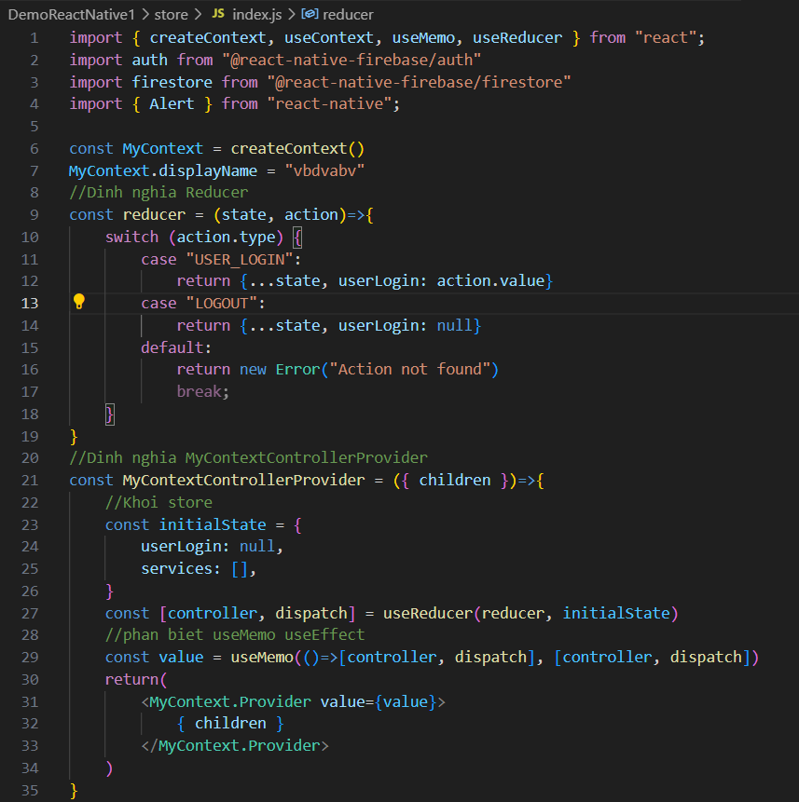

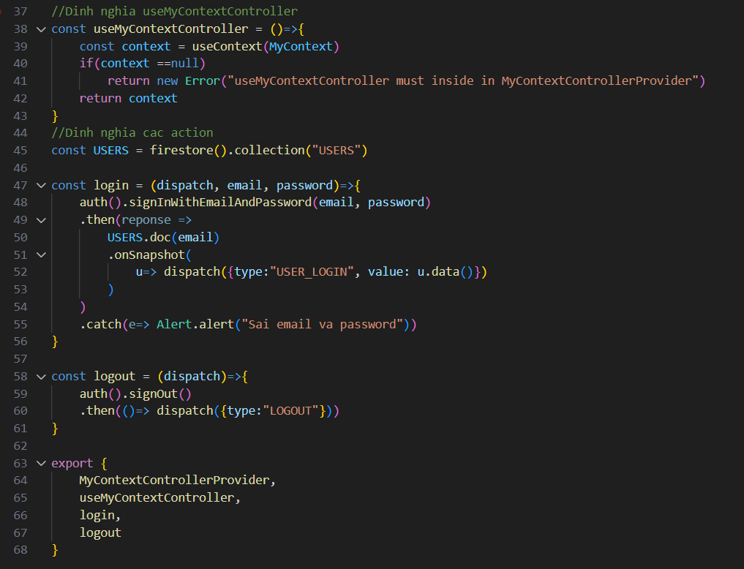

./App.js

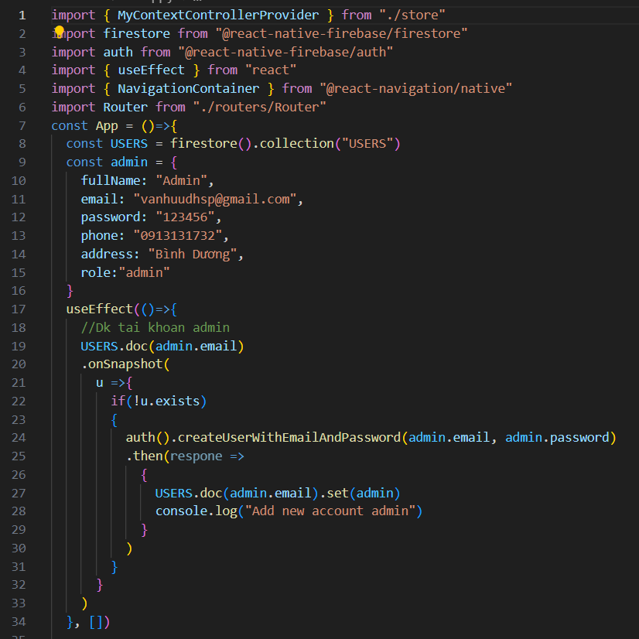

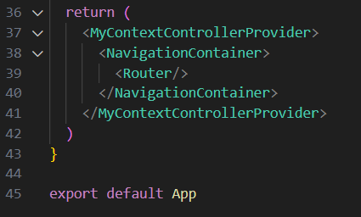

src/routers/Router.js

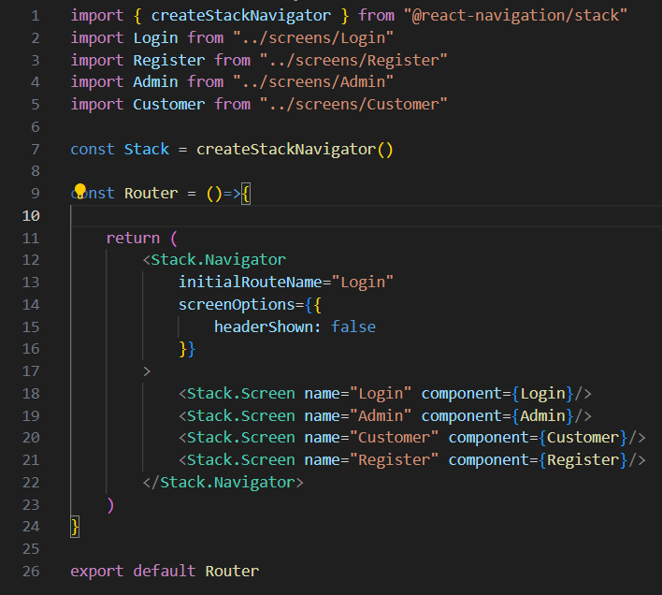

Src/screens/Login.js

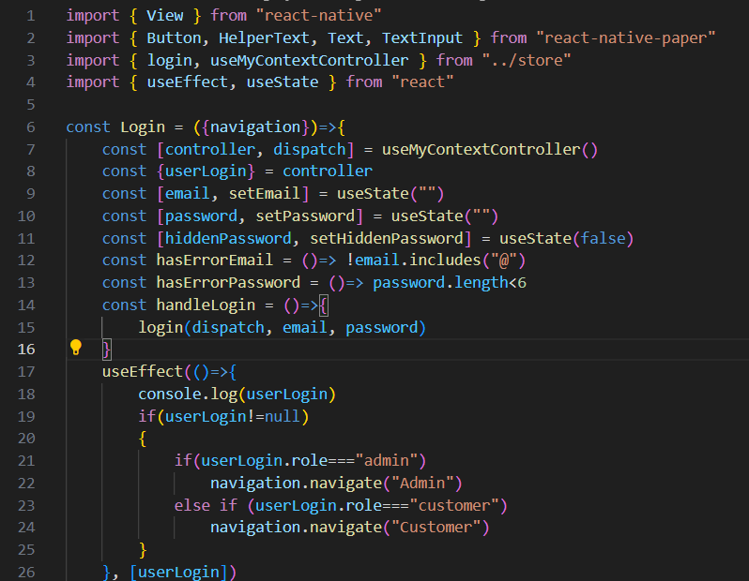

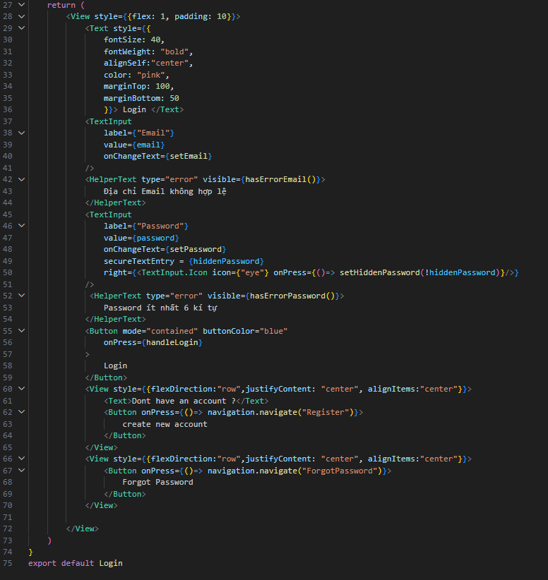

./screens/Register.js

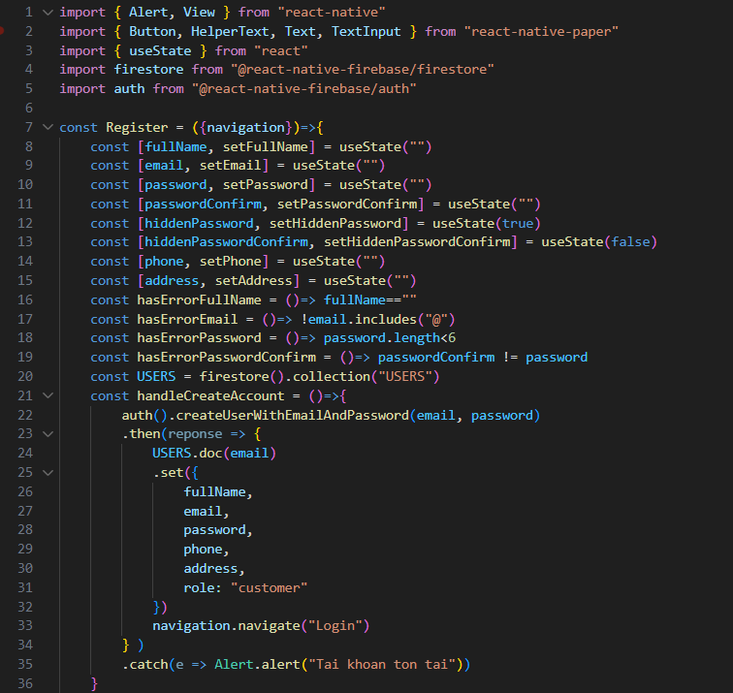

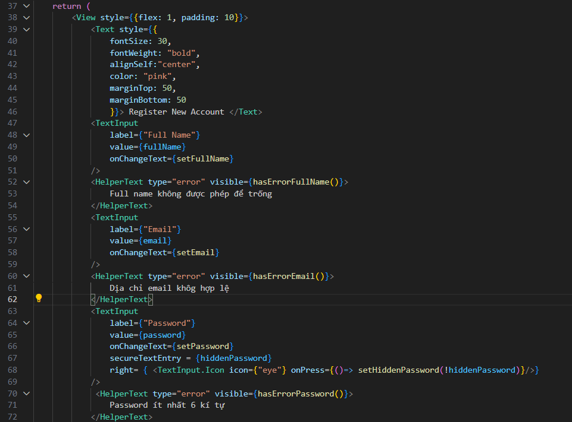

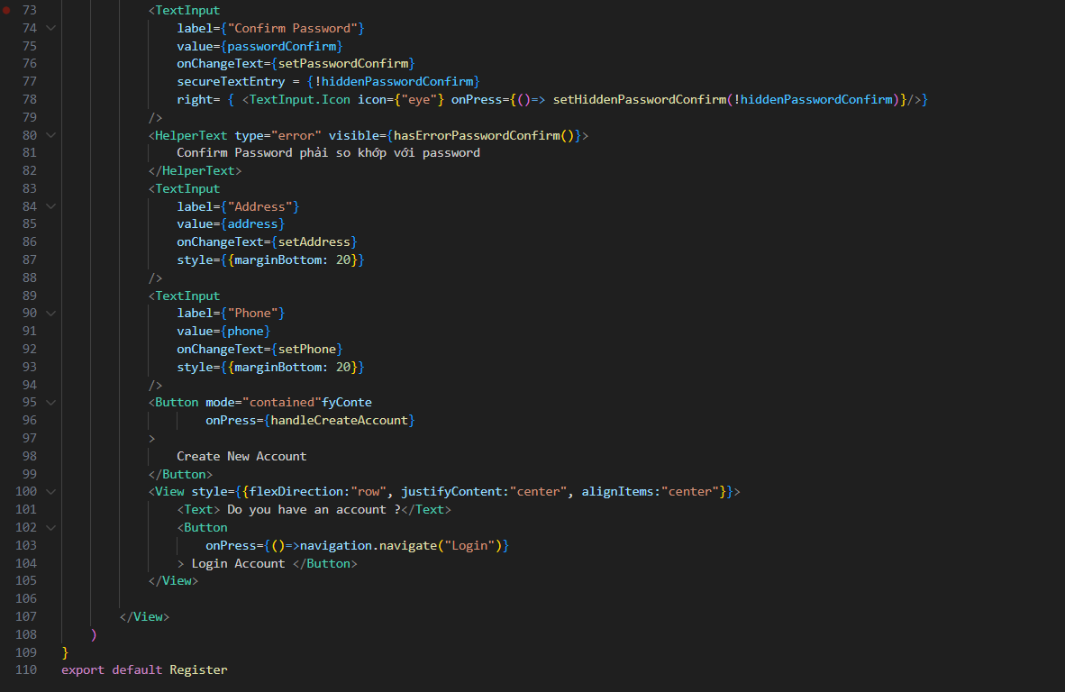

./screens/Customer.js

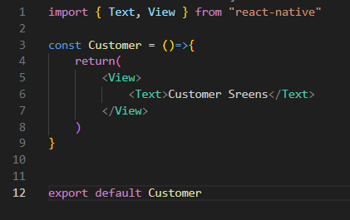

./screens/Admin.js

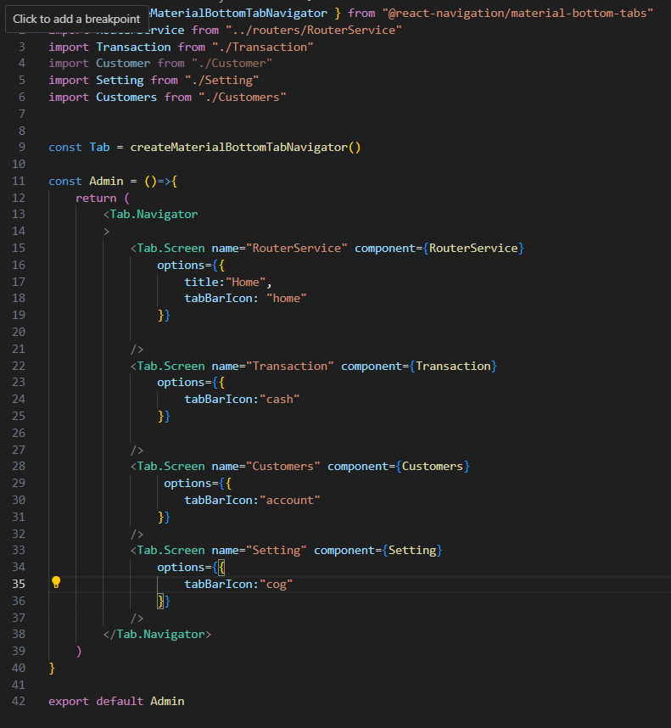

./screens/Setting.js

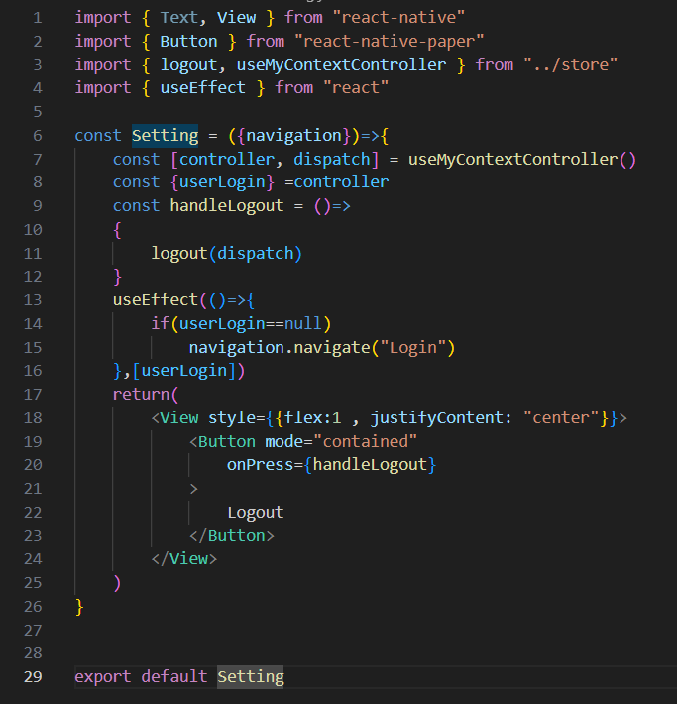

./screens/Customer.js

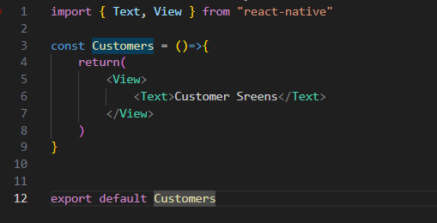

src/screens/Transaction.js

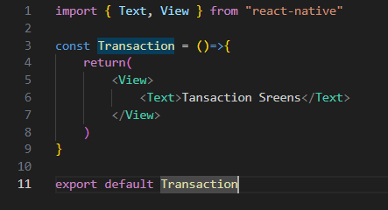

./routers/RouterService.js

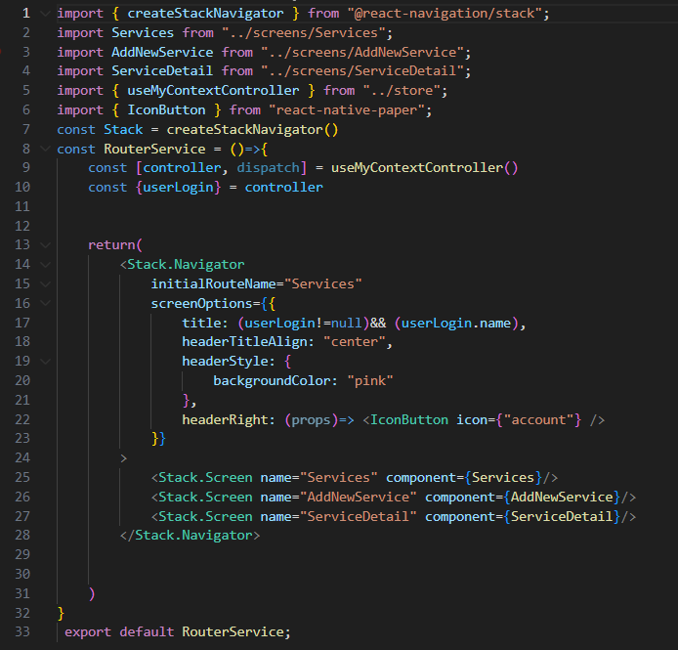

src/screens/Services.js

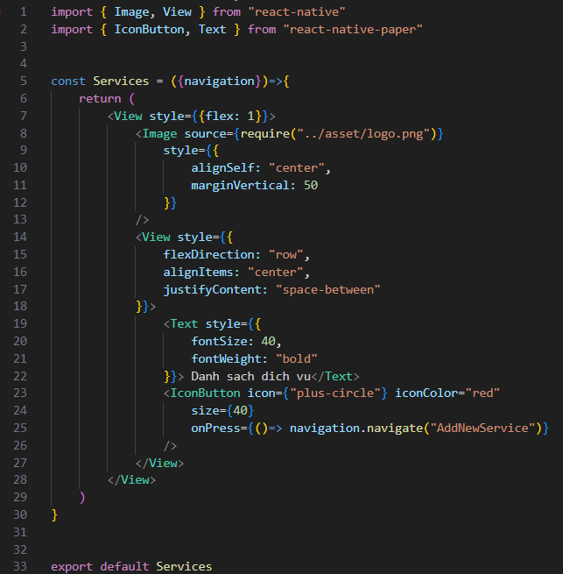

src/screens/AddNewService.js

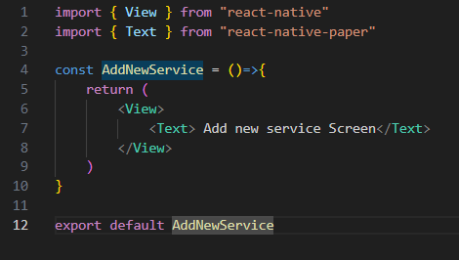

src/screens/ServiceDetail.js

